INTERPOLATE DATA VALUES FOR A STUDY AREA BASED ON SAMPLES
or
CREATE A CONTINUOUS SURFACE MAP FROM POINT DATA

In many of our exercises we collect point data (cell phone, temperature, pH) for a given area. These point data can be interpolated to create a continuous surface. Here are several hints that make interpolation more accurate.
The More Points The Better
Interpolated continuous surface maps are more accurate when you use more points and when the points are evenly distributed throughout the study area. When you have a defined study area, consider dividing the students into groups and having each group be responsible for a certain portion of the area. When the data are taken you can then MERGE the points and use the combined data for the interpolation. For example, here is a map of a campus that has been divided into four segments with student data taken in each segment. Notice how the points cover the entire study area.
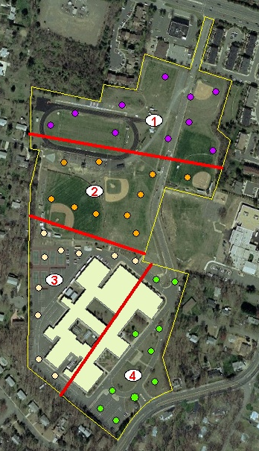

What Method of Interpolation Should I Use
IDW or Inverse distance weighted interpolation is the most commonly used method of interpolation. It assumes that the variation in the surface is being driven by local variation and it is best if the sample points are evenly distributed and not clustered.
Setting a Mask
A mask defines the area where you want the interpolation to be performed. For instance in this case we are only interested in points within the school parcel. Therefore we do not want the interpolation to go beyond the parcel. The parcel is the MASK that contains the interpolation.
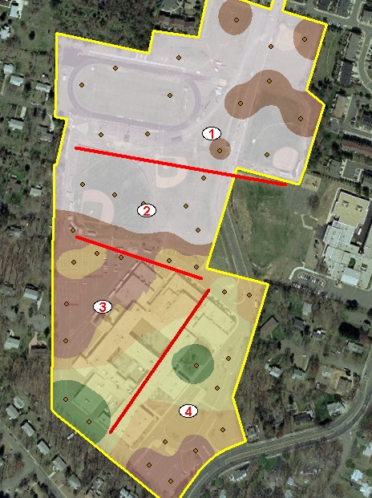
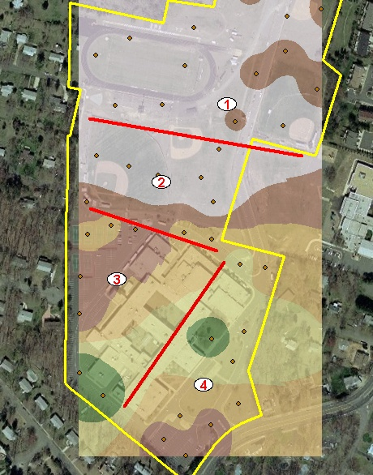
NO MASK MASK

To Full Extent
By specifying an extent, you define the area of interest where you want the interpolation to take place.
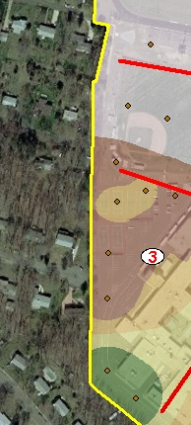
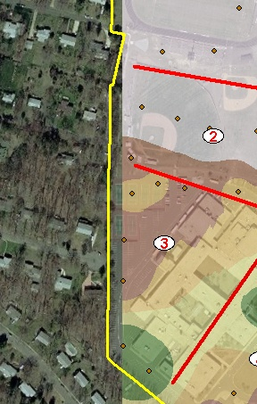
EXTENT NOT DEFINED EXTENT DEFINED AS TAX PARCEL

