INDEPENDENT WORK FOR STUDENTS USING ONLINE MAPPING
Online mapping allows students to ask questions, and create maps using just an Internet browser. Here are some suggestions.
Assignment:
http://www.nationalatlas.gov
Determine where people have the highest income in the United States? In Virginia?
Create your maps as deliverables.
Write an analysis of the map.
Explain Legends
Classification
Layers
Scale
Projection

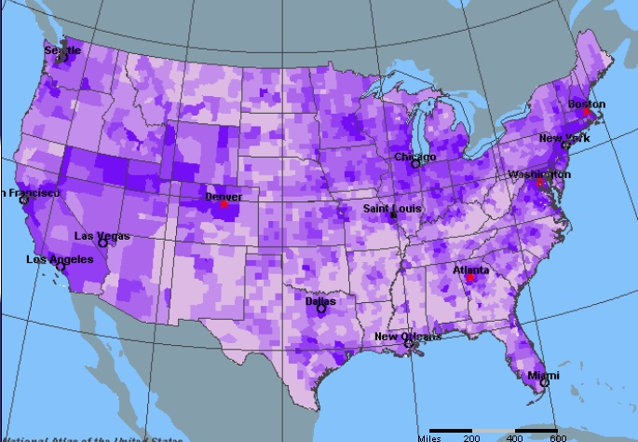

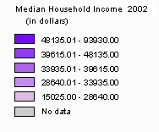

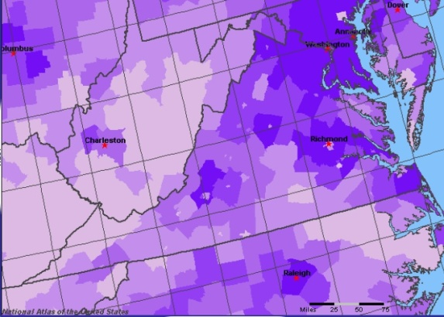
Sample Analysis
Both maps shown here are projected. The scale on both maps is 1:25 miles. People living on the east coast between Washington, DC and Boston, on the west coast (California between San Francisco and Los Angeles), and around Denver and Seattle have an average income of $45,000 to $95,000. People living on the border between the USA and Mexico and in the Mississippi Delta have an average income of $15,000 to $28,000 Dollars.

Northern Virginia, Richmond and Virginia Beach have the highest median income and southwest Virginia has the lowest median income.

The map consists of the following layers: North America, oceans, counties by median income and cities.

Assignment:
Explore your county GIS site. See what information you can find out about your place of residence.
http://www.fairfaxcounty.gov/maps/
http://www.fairfaxcounty.gov/gisapps/parcelviewer/parcels.asp?operation=ortho

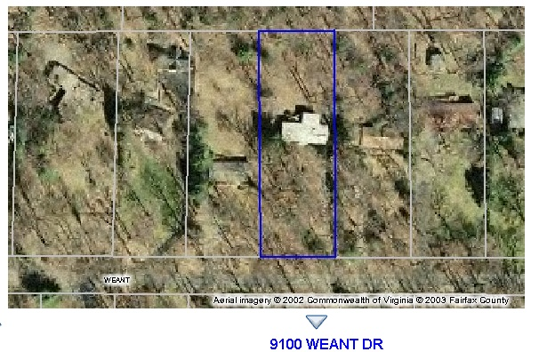

The layers inlcude aerial photography, tax parcels and buildings. The projection cannot be identified from the map but if you find the metadata on the website, the projection is specified as State Plane Feet. The resolution of the image is 2 feet.

Assignment:
http://www.geodata.gov
Climate
Display a map showing average annual precipitation in the United States.
Create your maps as deliverables.
Write an analysis of the map.
Explain Legends
Classification
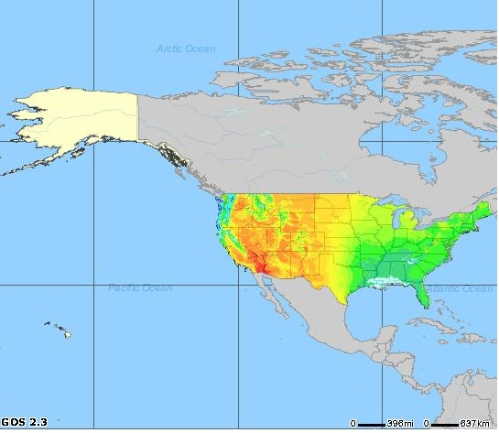
Layers
Scale
Projection
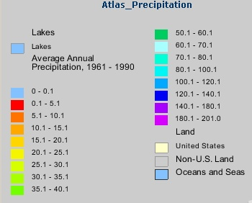

The map is not projected and the scale is 1:395 miles. The southeast United States has an average annual precipitation of 35 to 40 inches, the Midwest has an average of 20 to 25 inches and the southwest has an average of 5 inches. The layers are United States, oceans, non-U.S. land and precipitation.

